#### “LIBRARY MANAGEMENT SYSTEM”

**A PROJECT REPORT**

**Submitted in partial fulfillment towards the requirement of the degree of**

**BACHELOR OF COMPUTRE APPLICATIONS**

**(2018-2021)**

**Guided by: Submitted by:**

**Prof. Saloni Mehta Palak Rawat (18040DBCA0003414)**

**Gulshan Khakrey (18040DBCA0003407)**

**Shabana Khatun (18040DBCA0003423)**

**SHRI VAISHNAV VIDYAPEETH VISHWAVIDYALAYA, INDORE**

**SHRI VAISHNAV INSTITUTE OF COMPUTER APPLICATIONS**

**Approval**

The project entitled **“Library Management System”** submitted by **Palak Rawat (18040DBCA0003414) , Gulshan Khakrey (18040DBCA0003407)**

**, Shabana Khatun (18040DBCA0003423) of BCA VI** Semester is approved for the partial fulfillment towards the requirement of degree of **Bachelor of Computer Applications**.

**Internal Examiner External Examiner**

**Coordinator, SVICA**

Acknowledgement

We would like to take this opportunity to record our deep sense of gratitude to all those who helped us in achieving this target.

First and foremost, we would like to express our gratitude towards Dr. Anand Rajavat, Coordinator, Shri Vaishnav Institute of Computer Applications, for his constant support, motivation and valuable suggestions.

We are also grateful to **Mrs. Saloni Mehta** for extending all the facilities needed to carry out this project & reviewing the entire part of it with a great attention.

We extend our thanks to all other staff members of the institute.

**Palak Rawat (18040DBCA0003414)**

**Gulshan Khakrey (18040DBCA0003407)**

**Shabana Khatun (18040DBCA0003423)**

**Table of Contents**

1. Problem Investigation
   1. Introduction
   2. Goal and Objectives
2. System Analysis
   1. Information Gathering
   2. Feasibility Study
   3. Data Flow Diagram
   4. Hardware and Software Requirements
3. System Design
   1. ER Diagram
   2. Data Tables
4. Tool Used
   1. Front End
   2. Back End
5. Testing
6. Implementation
   1. Forms Layout

7. Conclusion

7.1 Salient Features of System

7.2 Limitations of System

7.3 Scope of Future Enhancements

1. Bibliography

**1 Problem Investigation**

* 1. **Introduction**

Library Management System is an application which refers to library systems which are generally small or medium in size. It is used by librarian to manage the library using a computerized system where he/she can record various transactions like issue of books, return of books, addition of new books, addition of new students etc.

Books and students maintenance modules are also included in this system which would keep track of the students using the library and also a detailed description about the books a library contains. With this computerized system there will be no loss of book record or member record which generally happens when a non computerized system is used.

All these modules are able to help librarian to manage the library with more convenience and in a more efficient way as compared to library systems which are not computerized.

* 1. **Goal and Objectives**

The project aims and objectives that will be achieved after completion of this project are discussed in this subchapter. The aims and objective are as follows:

* Online book issue.
* Request column for librarian for providing new books.
* A separate column for digital library.
* Student login page where student can find books issued by him/her and date of return.
* A search column to search availability of books.
* A teacher login page where teacher can add any events being organized in the college and important suggestions regarding books.
* Online notice board about the workshop.

**2. System Analysis**

**2.1 Information Gathering**

Since the mid-1990s the use of electronic resources has transformed information gathering for academic research. But it has affected subjects in different ways and to different degrees. Where previously finding information in all subjects was based around libraries, Library users studying different subjects nowadays do not go to the library in person but have convenient access to vast amounts of information from their desktops. In other subjects, electronic resources have been embraced, but visits to libraries are as important as ever and continue to form the basis of research projects with researchers regularly traveling abroad to use particular collections.

The information has been described as the fifth resource and need of man ranking after air, water, food, and shelter. “Information is data that has been processed into a form that is meaningful to the recipient and is of real or perceived value in current or prospective action or decisions”. There is an unbreakable chain of communication from the past to the present and present to the future.

**2.2 Feasibility Study**

Considering the requirements, a full scale feasibility study was undertaken for testing the possibility of computerization of BAMUL. The feasibility study was carried out under the following three areas :

(a) Technical Feasibility.

(b) Social Feasibility.

(c) Economic Feasibility.

**2.3 Data Flow Diagram**

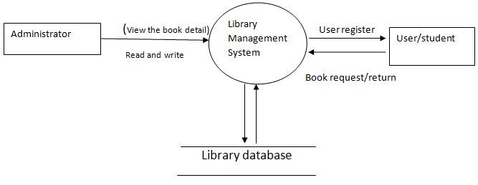

**2.4 Hardware and Software Requirements**

**Hardware Requirement**

**At Developer End**

1. Processor : Intel Dual core(similar or above).
2. Ram : 2 GB or above.
3. Storage Capacity : 20 GB or above.

**Software Requirement**

**At developer End**

**Language Used                   :**  Java (core).  
**Database                              :** My SQL.  
**User Interface Design       :**  Java SWING.  
**Web Browser                      :** Mozilla, Google Chrome.

**OS :** Window 7 or above.

**Software                           :** NetBeans 8.0, Java 8, MySQL.

**3. System Design**

**3.1. ER Diagram**

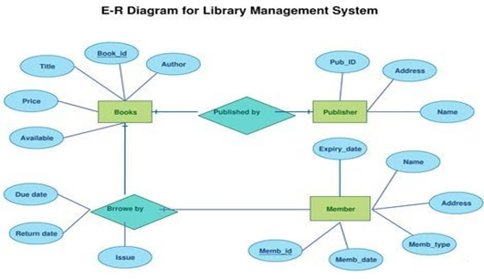

**3.2.Data Tables**

**3.2.1 Table Book**

|  |  |  |  |  |  |
| --- | --- | --- | --- | --- | --- |
| Field | Type | Null | Key | Default | Extra |
| book_id | varchar(10) | YES |  | NULL |  |
| name | varchar(40) | YES |  | NULL |  |
| isbn | varchar(20) | YES |  | NULL |  |
| publisher | varchar(30) | YES |  | NULL |  |
| edition | varchar(10) | YES |  | NULL |  |
| price | varchar(10) | YES |  | NULL |  |
| page | varchar(10) | YES |  | NULL |  |

create table book(book_id varchar(10), name varchar(40), isbn varchar(20), publisher varchar(30), edition varchar(10), price varchar(10), pages varchar(10));

**3.2.2 Table Student**

|  |  |  |  |  |  |
| --- | --- | --- | --- | --- | --- |
| Field | Type | Null | key | Default | Extra |
| student_id | varchar(10) | YES |  | NULL |  |
| name | varchar(25) | YES |  | NULL |  |
| father | varchar(25) | YES |  | NULL |  |
| course | varchar(10) | YES |  | NULL |  |
| branch | varchar(10) | YES |  | NULL |  |
| year | varchar(10) | YES |  | NULL |  |
| semester | varchar(10) | YES |  | NULL |  |

create table student(student_id varchar(10), name varchar(25), father varchar(25), course varchar(10), branch varchar(10), year varchar(10), semester varchar(10));

**3.2.3 Issue Book**

|  |  |  |  |  |  |
| --- | --- | --- | --- | --- | --- |
| Field | Type | Null | Key | Default | Extra |
| book_id | varchar(10) | YES |  | NULL |  |
| student_id | varchar(10) | YES |  | NULL |  |
| bname | varchar(40) | YES |  | NULL |  |
| sname | varchar(40) | YES |  | NULL |  |
| course | varchar(20) | YES |  | NULL |  |
| branch | varchar(10) | YES |  | NULL |  |
| dateOfIssue | varchar(30) | YES |  | NULL |  |

create table issueBook(book_id varchar(10), student_id varchar(10), bname varchar(40), sname varchar(40), course varchar(20), branch varchar(10), dateOfIssue DATE);

**3.2.4 Return Book**

|  |  |  |  |  |  |
| --- | --- | --- | --- | --- | --- |
| Field | Type | Null | Key | Default | Extra |
| book_id | varchar(10) | YES |  | NULL |  |
| student_id | varchar(10) | YES |  | NULL |  |
| bname | varchar(40) | YES |  | NULL |  |
| sname | varchar(40) | YES |  | NULL |  |
| course | varchar(20) | YES |  | NULL |  |
| branch | varchar(10) | YES |  | NULL |  |
| dateOfIssue | varchar(30) | YES |  | NULL |  |
| dateOfReturn | varchar(30) | YES |  | NULL |  |

create table returnBook(book_id varchar(10), student_id varchar(10), bname varchar(40), sname varchar(40),course varchar(20), branch varchar(10), dateOfIssue varchar(30), dateOfReturn varchar(30));

**3.2.5 Table Account**

|  |  |  |  |  |  |
| --- | --- | --- | --- | --- | --- |
| Field | Type | Null | Key | Default | Extra |
| username | varchar(20) | Yes |  | Null |  |
| name | varchar(25) | Yes |  | Null |  |
| password | varchar(25) | Yes |  | Null |  |
| sec_q | varchar(25) | Yes |  | Null |  |
| Sec_ans | varchar(25) | Yes |  | Null |  |

create table account(username varchar(20), name varchar(25), password varchar(25), sec_q varchar(25), sec_ans varchar(25));

**4. Tool Used**

**4.1. Front End**

* + SWING CONCEPT

Swing in java is part of Java foundation class which is lightweight and platform independent. It is used for creating window based applications. It includes components like button, scroll bar, text field etc. Putting together all these components makes a graphical user interface.

**4.2. Back End**

* JAVA

**Java** is used as the server-side language for most back-end development projects, including those involving big data and Android development. Java is also commonly used for desktop computing, other mobile computing, games, and numerical computing.

* My SQL

**MYSQL** is a relational database management system based on SQL – Structured Query Language. The application is used for a wide range of purposes, including data warehousing, e-commerce, and logging applications. The most common use for MYSQL however, is for the purpose of a web database.

**5. Testing**

The aim of the system testing process was to determine all defects in our project .The program was subjected to a set of test inputs and various observations were made and based on these observations it will be decided whether the program behaves as expected or not.

1.Unit testing.

2.Integration testing.

5.1. Unit Testing

Unit testing is undertaken when a module has been created and successfully reviewed .In order to test a single module we need to provide a complete environment i.e. besides the module we would require

* + The procedures belonging to other modules that the module under test calls.
  + Non local data structures that module accesses.
  + A procedure to call the functions of the module under test with appropriate parameters.

1. **Test For the admin module**
   * Testing admin login form-This form is used for log in of administrator of the system. In this we enter the username and password if both are correct administration page will open otherwise if any of data is wrong it will get redirected back to the login page and again ask for username and password.
   * Student account addition- In this section the admin can verify student details from student academic info and then only add student details to main library database it contains add and delete buttons if user click add button data will be added to student database and if he clicks delete button the student data will be deleted.
   * Book Addition- Admin can enter details of book and can add the details to the main book table also he can view the books requests.
2. **Test for Student login module**

* Test for Student login Form-This form is used for log in of Student .In this we enter the library id, username and password if all these are correct student login page will open otherwise if any of data is wrong it will get redirected back to the login page and again ask for library id, username and password.
* Test for account creation- This form is used for new account creation when student does not fill the form completely it asks again to fill the whole form when he fill the form fully it gets redirected to page which show waiting for conformation message as his data will be only added by administrator after verification.

1. **Test for teacher login module-**
   * Test for teacher login form- This form is used for login of teacher .In this we enter the username and password if all these are correct teacher login page will open otherwise if any of data is wrong it will get redirected back to the login page and again ask for username and password.

**5.2. Integration Testing**

1. In this type of testing we test various integration of the project module by providing the input.
2. The primary objective is to test the module interfaces in order to ensure that no errors are occurring when one module invokes the other module.

6. Implementation

6.1 Form Layout

1. User login frame

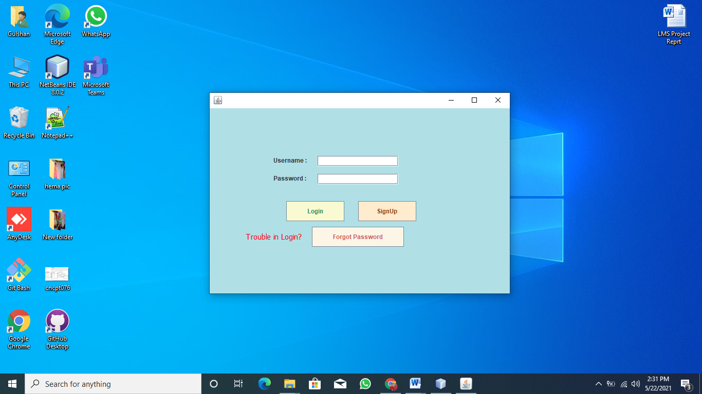

2.Loading Frame

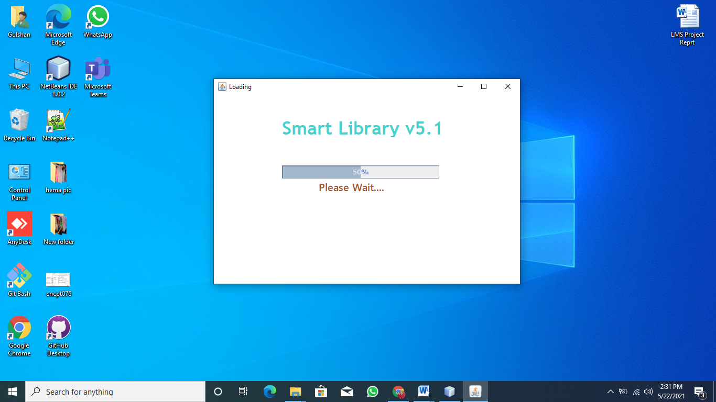

3.Create Account Frame

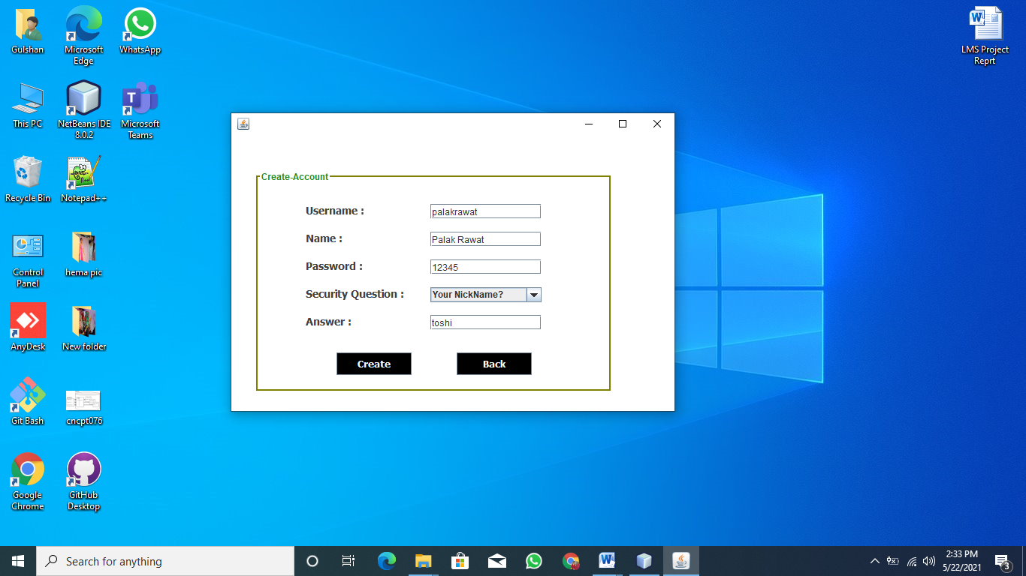

4.Forgot Panel frame

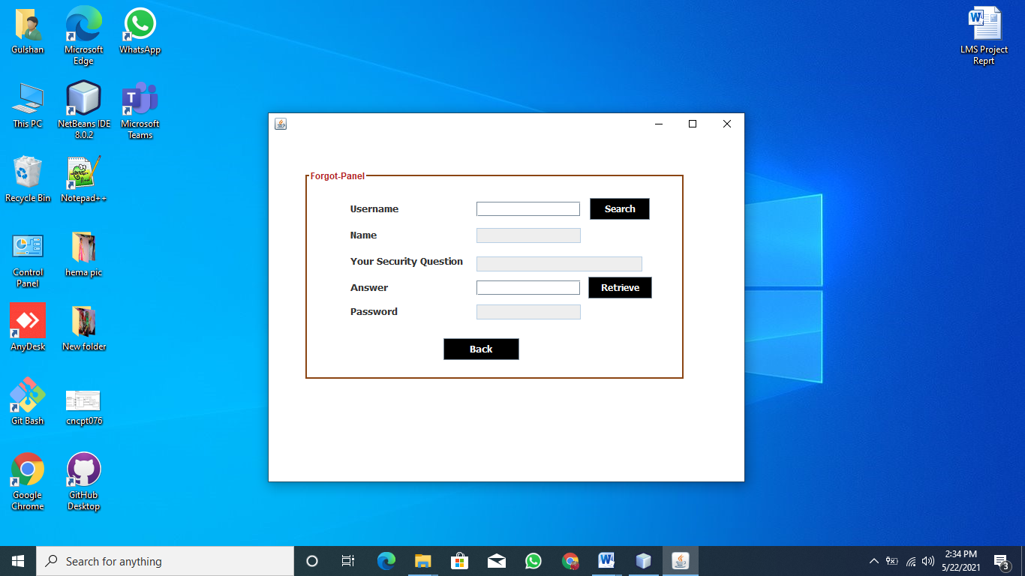

5.Home page Frame

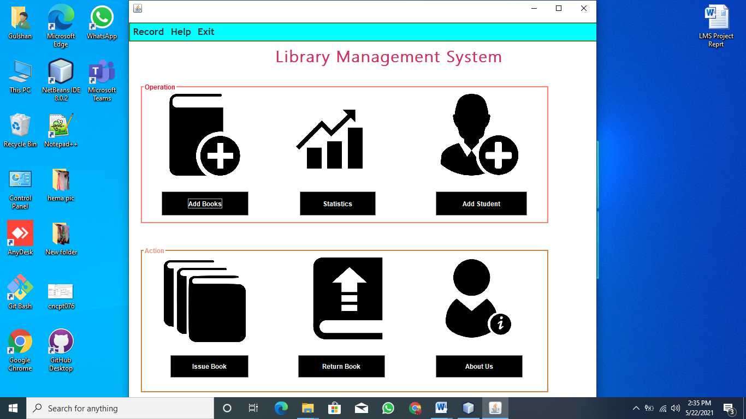

6.Add Book Frame

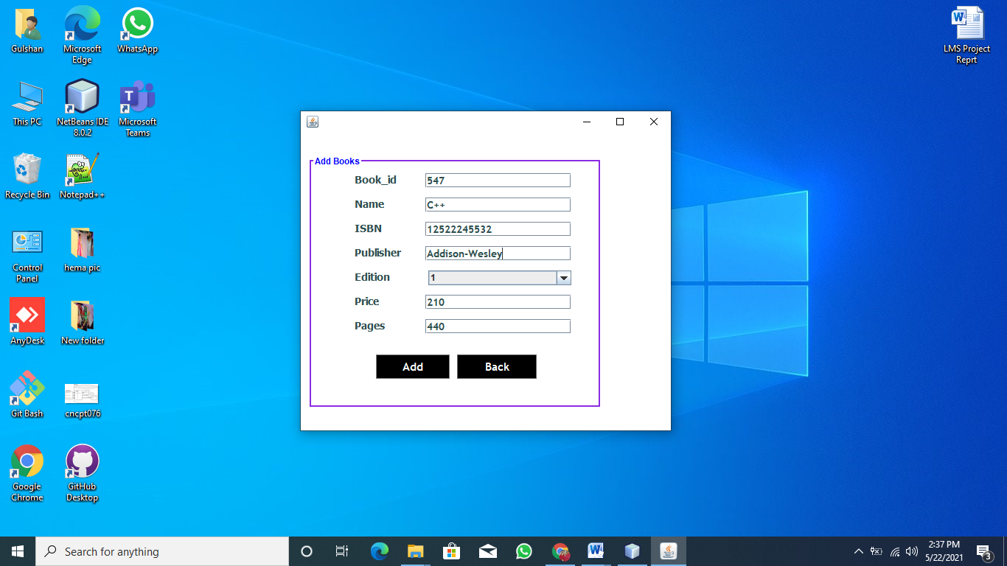

7.Add Student Frame

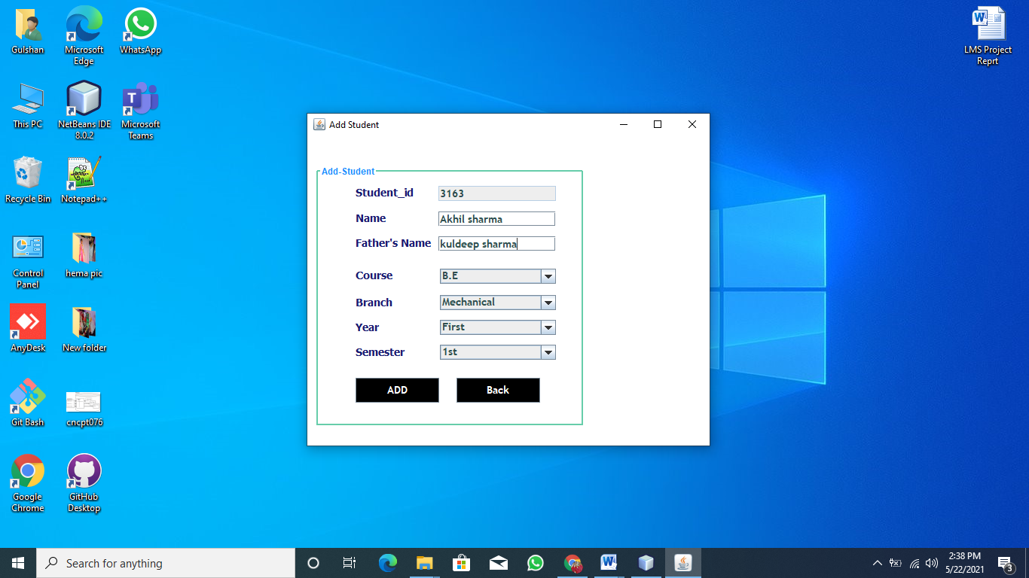

8. Issue Book Frame

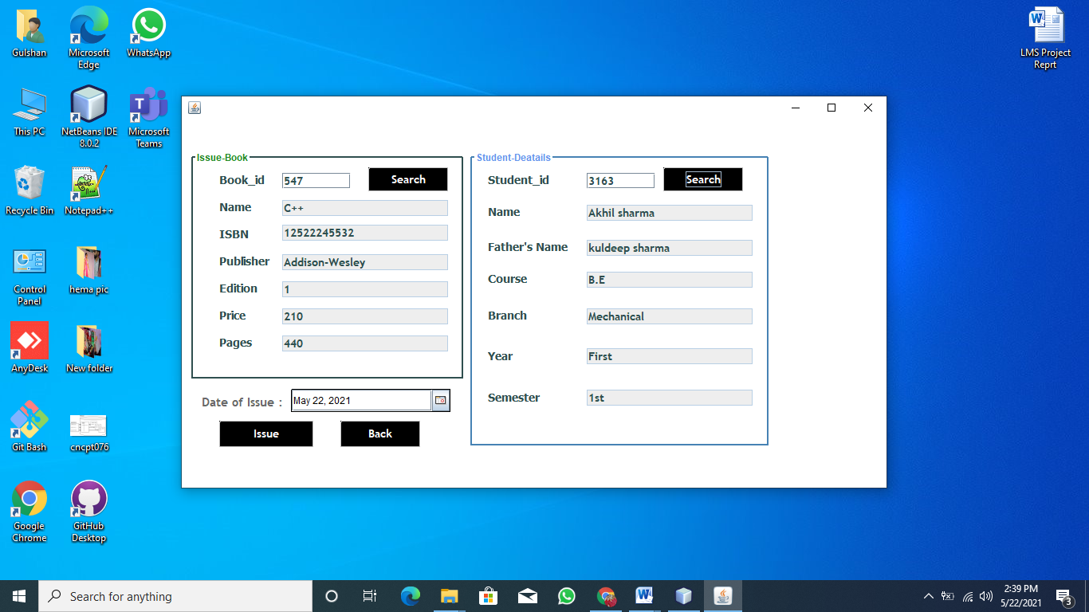

9.Return Book Frame

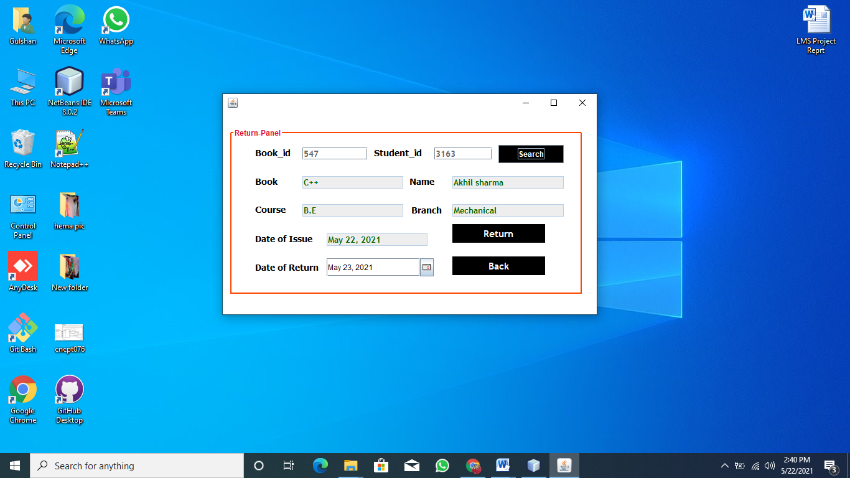

1. **Conclusion**
   1. **Salient Features Of System**

This web application provides a computerized version of library management system which will benefit the students as well as the staff of the library.

It makes entire process online where student can search books, staff can generate reports and do book transactions. It also has a facility for student login where student can login and can see status of books issued as well request for book or give some suggestions. It has a facility of teacher’s login where teachers can add lectures notes and also give necessary suggestion to library and also add info about workshops or events happening in our college or nearby college in the online notice board.

7.2 Future Scope

There is a future scope of this facility that many more features such as online lectures video tutorials can be added by teachers as well as online assignments submission facility, a feature Of group chat where students can discuss various issues of engineering can be added to this project thus making it more interactive more user friendly and project which fulfills each users need in the best way possible

**8. Bibliography**

* <http://www.w3schools.com/html/html_intro.asp>
* <http://www.w3schools.com/css/css_background.asp>
* <http://www.w3schools.com/js/js_datatypes.asp>
* <http://www.w3schools.com/sql/sql_insert.asp>
* <http://www.w3schools.com/sql/sql_update.asp>
* <http://www.w3schools.com/php/php_forms.asp>
* https://youtu.be/G11sFijYjQM.com